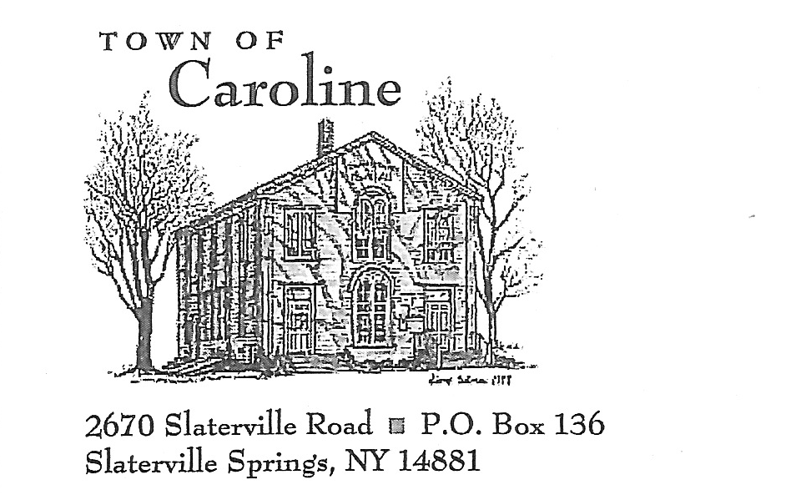
April 25,2019
Mr. Mark Fuentes Response: May 7, 2019
3391 Cambier Road
Marion, NY 14505

Re: Town of Caroline Special Use Permit Application for Telecommunications Tower Sited at 340 Bald Hill Road, Brooktondale, NY Tax Parcel 15.-1-58

Dear Mr. Fuentes,

The Town of Caroline received Special Use Permit Application for Telecommunications Tower Sited at 340 Bald Hill Road, Brooktondale on March 28, 2019 and has reviewed its contents for completeness. The Review Board has found the following deficiencies that need to be corrected before the Review Board can begin its review.

Application requirements stated in Town of Caroline Local Law #2 of 1998 “Regulating the Siting of Telecommunication Towers, Antennae, and Related Facilities”

- Documentation for this particular parcel (15.-1-58) for siting: Section 6G, Section 7, and Section 8 (co-location within 4 miles). Narrative stating existing and planned co-location and whether there are other opportunities for co-location within 4 miles. Response: Propagation maps supplied on March 28, 2019, April 15, 2019 and May 6, 2019 show current, future and proposed coverage. There are no existing towers or structures within a 4 mile radius tall enough to co-locate on and provide the proposed coverage.
- Tower Specifications: Section 6- f (10, 11, 20), H,W, [Note a request for conditional approval of this permit for data that will be developed after permit is approved and with building permit application is permissible.] Response: Tower and foundation drawings will be supplied to the town after issuance of special use permit and prior to construction start. The construction team needs the permit in hand before they can order the foundation design and tower. Documents will be sent to code officer Brooke Greenhouse for approval prior to construction start.
- Current submission of documentation to justify variance of Tower Height insufficient and incomplete (Section 9). Specify on a surface map the line of cross section graphic, and critical points along that line. Also supply coverage map if tower were 144ft vs 195ft. Please include a narrative explaining the purpose of any maps or graphs or photos and why it is important to the variance, as well as other considerations. Response: May 6, 2019 revised propagation maps sent to review board show current, future and proposed coverage along with antenna coverage at 135’ and 195’. The antennas at 195’ provide more coverage to the town of Brooktondale and Caroline.
- Right to Site on this Parcel: please submit a copy of signed lease, and a statement from land owner to meet the requirements of Section 6 C. Include in this documentation a recognition by lessor of “ice fall” hazard (Section 13) Response: As of May 1, 2019 Lease currently with land lord for execution. Awaiting the return FedEx package to be delivered to me.
- Please submit information confirming no interference with Tompkins County 911 communications. Response: May 3, 2019 Jack Crance Tompkins Department of Emergency Response stated the proposed AT&T tower location will not interfere with their existing towers, copy of email provided to the review board on May 7, 2019.
- Section 6F 23 please discuss impacts on adjacent property held by Finger Lakes Land Trust and Cornell Plantations and on the Finger Lakes Trail. Note: The Review Board would like copies of communications with the Land Trust and Cornell Plantations. Also, this section needs to address impacts on nearby State Forests, specifically animal impacts other than birds. Response: Revised Viewshed map emailed to review board May 7, 2019. Phase 1 Environmental Site Assessment and the National Environmental Policy Act (NEPA) Screening reports which cover wildlife are underway and will be submitted to the review board upon completion.
- Maintenance and inspection information is required (Section 6 F 16 of local law) Response: Tower EIA-TIA reports are performed every five (5) years, emergency maintenance would be a case by case basis.
- Detailed site plan needs correction of proposed topography. As currently submitted it labels a single contour as both 1630 and 1633 feet. Response: Revised drawings submitted to review board on May 6, 2019.
- Section 30 describes the process for requesting waivers and conditions for preliminary approval. For the Review Board’s paper trail, we need written request for waivers (height) and conditions (structural and subsurface morphology and maybe others). Response: Waiver for the 199’ foot tower was requested in the original submission dated March 28, 2019. New propagations page seven with antennas at 135’ and page eight with antennas at 195’ show the difference in coverage. The taller the tower the better the coverage is getting over the hill located on Bald Hill Road.
- We will need an Ag Data Statement filled out. Response: Document sent to review board 5/7/2019.

The application also includes the project’s proposed EAF. Please consider these adjustments:
- Page 13 E3h: We believe there a two NYS Forests within 5 miles of this site. Also please review Tompkins County Unique Natural Resource Inventory Response: Revised EAF emailed to review board May 7, 2019.
- Page 11 E.2.h iv. Since iii is answered yes, then iv needs to be filled in Response: Revised EAF emailed to review board May 7, 2019.
- Page 7 D2 k i. listed as amperage, needs to be KWH Response: Revised EAF emailed to review board May 7, 2019.
- Please make sure the Visual EAF Addendum Supplemental Data form aligns with the Visual Impact map. Map needs to show Finger lakes Trail, Finger lakes Land Trust land, and Cornell Natural Areas. Response: Revised EAF addendum and viewshed map emailed to review board May 7, 2019.

Any items that the applicant would like to request to be conditions to the approval, instead of supplying the appropriate information at this time, these requests must be made in writing.

Please submit these items to the Town of Caroline Code Enforcement Officer

